**Appendix 1: Assignment submission cover sheet**

**ASSIGNMENT SUBMISSION COVER SHEET**

**Student Id:**

cse24-024

**Student names:**

Angel Sebaga Sebudula

**Student email:**

cse24-024@thuto.bac.ac.bw

**Cohort:**

CSE24

**Assignment title: E**

SystemDocumentation

**Date of submission:**

19.Sep2025

**Programme of Study: BSC**

BSC Computer Systems Engineering

**Year of Study:**

2025



**Intellectual property statement**

By checking the box below, I certify that this assignment is my own work and is free from plagiarism. I understand that the assignment may be checked for plagiarism by electronic or other means and may be transferred and stored in a database for the purposes of data-matching to help detect plagiarism. The assignment has not previously been submitted for assessment in any other unit or to any other institution.

**I have read and understood the Botswana Accountancy College plagiarism guidelines policy.**

**☐ Agree 19/09/2025**



**Signature……………………………………. Date………………………………………….**



**PART A:SYSTEM DOCUMENTATION**

**1.REQUIREMENTS ELICITATION**

**1.1 FUNCTIONAL REQUIREMENTS**

We had an interview at 1030am at the teams app and it ended at 1216pm.The interviewee was Mr Kentsenao Baseki and the interviewer was Angel Sebudula.

***Question1:*** *I wanted to ask if the monthly interest should require human approval before finalization or they should be fully automated?*

**Answer:**  
“It must be fully automated.” The system should automatically calculate and apply the interest based on the account balance at the time.

**QUESTION 2**: *So after the system fully generates or automates that transaction, the has to be like monthly statements steady set. Or are those not necessary in this case, like the transaction is still?”*  
**Answer:**  
Yes, the automated interest payment is a transaction and must be recorded in the transaction history. It should show the date, the type of transaction (e.g., "interest credit"), the amount credited, and the new balance.

**QUESTION 3:** *beyond the basic details, what customer information is most critical to store?*  
**Answer:**As the analyst, you must break down the scenario. For an individual, you might need date of birth, national ID, and next of kin. For a company, you might need the company number, date of incorporation, and signatories. General customer attributes like address and contact number should be inherited by both.

**QUESTION 4:** *I wanted to get clarification on the currency we should use. Should we stick to U.S. dollars or Pula and is that limit? What is the limit on deposit and withdrawals for each individual account?”*  
**Answer:**  
The specific currency (pula, dollar, etc.) doesn't matter. What matters is the data structureand OO design. The limits are given in the scenario: a minimum of 50 pula to open a Savings account and 500 pula to open an Investment account. A Cheque account can start at 0.

**1.2 NON FUNCTIONAL REQUIREMENTS**

***QUESTION :*** *Should we add a system that can handle incorrect login attempts, like maybe an account can log out after three tries.* **Answer:**No, the focus is not on these extra features. The core objective is to assess your understanding and application of OO concepts and principles (abstraction, inheritance, polymorphism, etc.). Adding such features is not worth the "budget".

**QUESTION:** *So prior you mentioned that we shouldn't really focus on login and credentials if it's not working. Would it apply here where if a person doesn't have enough money to display?*  
**Answer:**  
This is required. An error message must be displayed if a user tries to withdraw more money than they have. However, this failed transaction should not be recorded in the transaction history.

**2.STRUCTURAL MODELLING**

**USE CASE DIAGRAM**

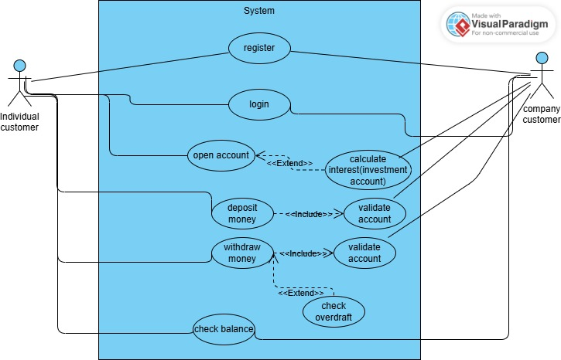

**CLASS DIAGRAM**

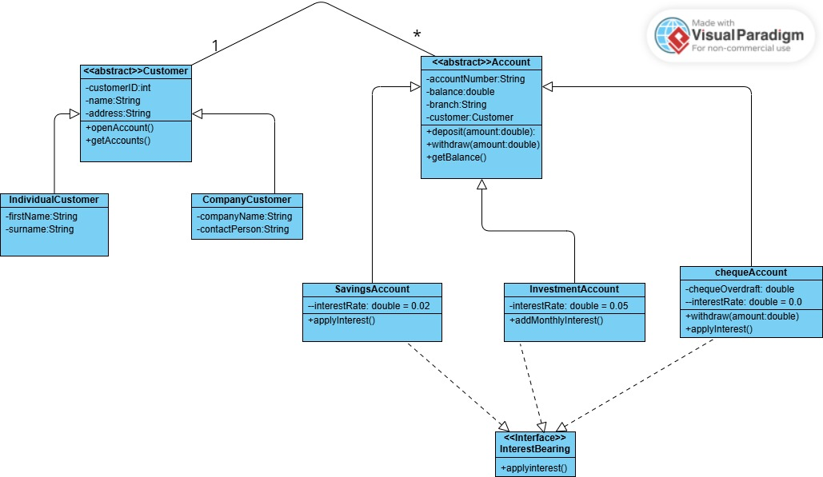

**3.BEHAVIOURAL MODELING**

**3.1 DEPOSIT SEQUENCES**

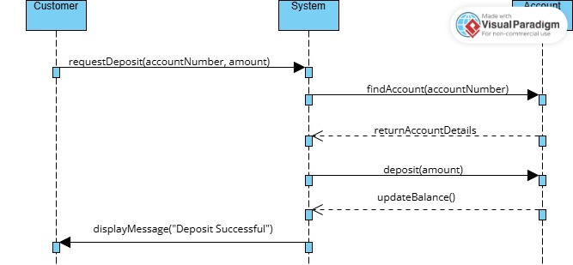

**LOGIN SEQUENCE**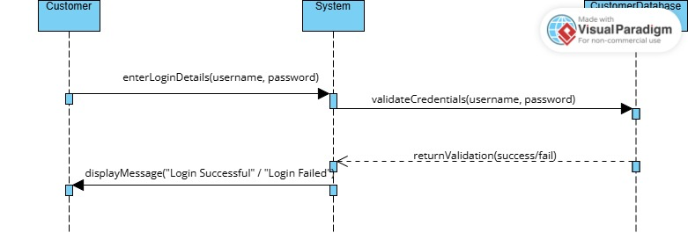

**STATE DIAGRAM**

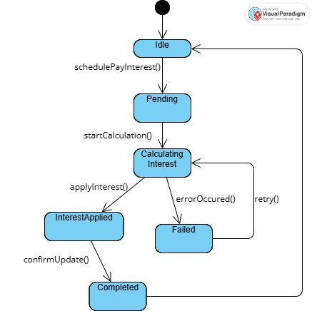

**MEETING RECORD APPENDIX**

[**OOAD Elicitation Session-20250918_103316-Meeting Recording.mp4**](https://mybac.sharepoint.com/:v:/s/20252026cse202objectorientedanalysisanddevelopmentwithjav/ETK2KNDOJNNCgI3WOcFy_XUB57nHHAzNSlG9JaieWIF_jg?e=mDQR8p)